PHYSICS 357S - Problem Set #3 - February 2014

Distributed 10th Feb and be handed in by 3rd March before 17:00. Please have a look at the problem set when it comes out. Decide whether it is going to cause you trouble or not…. And ask questions well before the due date. The problem sets are supposed to give you an opportunity to ask questions. There are 10 questions. As usual, keep an eye out for typos! I am not a very good typist.

(1) The interaction of neutrons with bulk matter is very different from the interaction of charged particles and photons. The neutrons do not have an electromagnetic interaction. When a beam of neutrons enters a target it will start to lose energy through inelastic scattering with nuclei. If the target is large enough the neutrons are slowed down by this repeated inelastic scattering. This is called moderating the neutron beam. Slow neutrons can have very large cross sections for inelastic interactions with nuclei. This is why a fission reactor needs a moderator in order to slow the neutrons from one fission generation down to the point where they will have a large probability of causing fission in another nucleus; and hence keep a chain reaction going.
As a result of this slowing down process, neutrons reach a state in which their energies are in equilibrium with those of the atoms in the material of the moderator. In this case the neutrons may gain or lose a small amount of energy in each collision; but in a large number of collisions between the neutrons and the atoms of the moderator, energy gains are as probable as energy loss. The neutrons are then thermal neutrons.
The capture cross section for thermal neutrons on 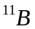 is 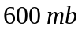 (millibarns). On the average how far can a beam of such neutrons penetrate a slab of ( density = 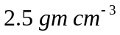) before half the beam is absorbed? 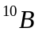 has a capture cross section for thermal neutrons of about 50,000 b (barns). What is it used for in nuclear reactors?

(2) If one had a particular stable nuclide, one might want to fire neutrons into it and change it into a new nuclide with more neutrons. This is how some of the transuranic elements were made. The bombarded nuclides can fly apart into lighter nuclides, or they might fuse. By studying these nuclear reactions, a great deal has been learned about the internal dynamics of nuclei. There are also various practical applications. Thermonuclear weapons get some (secret) amount of their yield from:
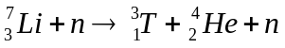.
The cross section for this is probably a secret, so I can’t do a calculation on it. However, a much better application is in a fusion reactor, where most of the energy will come from the reaction
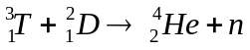.
At an energy of 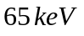this produces 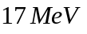neutrons. These are absorbed in the walls of the reactor ( a Tokamak) according to
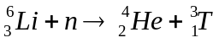,
producing heat and more 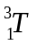. Let’s consider the reaction . It has a cross section of 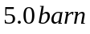. In a 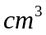of 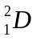,calculate what fraction of the is used up in a year, if the incident flux of is 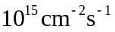.

(3) A finely collimated beam of α−particles having a current of 2 μΑ bombards a metal foil of thickness 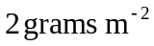 (these may seem like odd units, but it is just [density x thickness in metres]) of a material of atomic weight 107.8. A detector of area 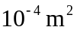 is placed an angle of 8 degrees, at a distance of 0.2 m from the foil so that the α−particles strike it normally on average; the detector counts at a rate of 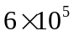particles 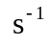. Calculate the differential cross-section for the scattering process at the particular angle of measurement.

(4) A liquid hydrogen target of volume 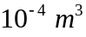 and density 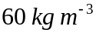 is immersed in a broad, uniform, monoenergetic beam of negative pions. The flux of pions in the beam is 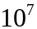 particles 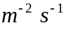. At a sufficiently low enough beam momentum ( below around 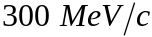) the only reaction we have to consider is
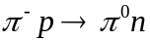
which occurs with a cross section of 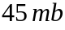( 45 millibarns is equal to 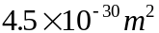). The neutral pions decay in the mode 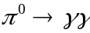 with a very short lifetime, so that all the decays occur within the target. Neglect any attenuation of the incident beam in the target and calculate the number of - rays emitted per second from the target. What elementary force causes the neutral pion to decay?

(5) Consider an accelerator which collides beams of electrons and protons. The circulating beams of electrons and protons are traveling at essentially the speed of light. The electron and proton beams actually consist of bunches of particles. For both the electron and proton beams, the bunches are 2 cm long (in the direction of motion) and they are circulating in rings of 300 m circumference. Each ring contains 100 bunches. Each of these bunches contains 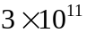particles, and the circulating frequency is 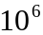/sec for each beam. This means that 100 x bunches collide with each other each second. Now assume that the particles are distributed uniformly over a cross sectional area of 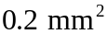, and this is also the area of the intersecting area of the beams.
(a) Determine the luminosity of this accelerator.
(b) If the cross section for collisions is 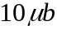, determine the number of scattering events which would be observed in a counter (or experiment) which completely surrounded the intersection region.
(c) Find the average flux of electrons.
(d) Consider the situation where, instead of colliding with the proton beam, the beam of electrons is extracted from the machine, and scatters from a stationary target of liquid hydrogen (density ≈ 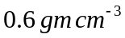) which is 2 cm long. In this case find the number of scattering events. Compare this with your answer in (b). Note that you have to assume that the cross section for ep collisions is independent of the centre-of-mass energy. This is clearly not realistic.

This problem is based on the accelerator HERA, located in Hamburg Germany, at which the UofT group performed experiments to determine the momentum distribution of quarks inside the proton. Parts of the accelerator were built by TRIUMF in Vancouver and Atomic Energy of Canada Limited (AECL) at the Chalk River Laboratory (north of Ottawa)

Note on Addition of Angular Momenta
In the addition of angular momentum the Clebsch-Gordan coefficients, 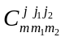, are defined by
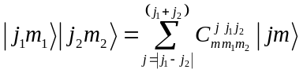 with 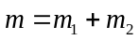
The Clebsch-Gordan coefficients give the probability of getting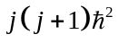, if we measure total angular momentum squared , 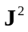, of a system consisting of two angular momentum states 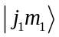 and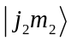. The probability is the square of the corresponding Clebsch-Gordan coefficient. The book by Griffiths, page 113, is a useful reference on this. I essentially use his approach. You can find the Clebsch-Gordan coefficients at http://pdg.lbl.gov/2013/reviews/rpp2012-rev-clebsch-gordan-coefs.pdf

(6) (a) Suppose that you have two particles of spin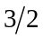, each is in a state with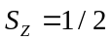. Assume that the orbital angular momentum between these particles is zero. What values would you get for the total angular momentum of the system? What is the probability of each value? Explicitly calculate the sum of these probabilities.
(b) A particle has intrinsic spin 2, and is in a 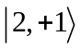 state. It decays to a spin 1/2 particle and a spin 3/2 particle, which have no relative orbital angular momentum. What is the probability of finding the spin 1/2 particle in the state 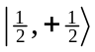? In this case, what is the spin state of the 3/2 particle?

(7) There is a whole zoo of mesons which contain c-quarks and b-quarks. The masses of these quarks are 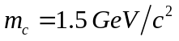 and 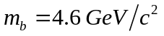. The 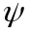 meson has a mass of 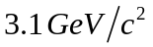 and is a bound state of 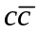, and 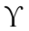has a mass of 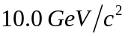 and is a 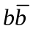 bound state. The force binding the quark anti-quark pair is the QCD. Notice that the mass of the bound state in each case is close to the sum of the masses of the quarks involved. This means that the quarks don’t have much energy in their relative motion, or that their kinetic energies are small compared with their rest masses. So, these are non-relativistic bound states. The energy levels of these quark anti-quark bound states can be essentially calculated in just the same way as the energy levels of positronium (what’s that?).
a) These mesons are both spin-1. What does that tell you about the possible angular momentum states of the quarks?
b) Assume that the spins of the are aligned. What is the magnetic moment of the ?
c) Assume that they are anti-aligned. What is the magnetic moment of the . (assume some simple semi-classical picture of the relative motion of the two quarks)

(8) The following table lists the flavour quantum numbers for several particles. Using this table, and your knowledge of three quark generation charges and flavours, write down the quark content for these particles. For cases where a particle is a mixture of quark combinations, such as 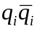 (where i can run over several flavours), it is not necessary to write down any normalizations or phases; a list of quark combinations is adequate.

BARYONS | Strangeness | Charm | Beauty  (Bottom)
n | 0 | 0 | 0
p | 0 | 0 | 0
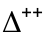 | 0 | 0 | 0
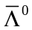 | +1 | 0 | 0
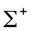 | -1 | 0 | 0
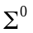 | -1 | 0 | 0
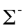 | -1 | 0 | 0
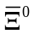 | +2 | 0 | 0
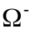 | -3 | 0 | 0
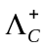 | 0 | +1 | 0
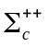 | 0 | +1 | 0
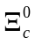 | -1 | +1 | 0
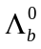 | 0 | 0 | -1
MESONS
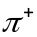 | 0 | 0 | 0
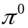 | 0 | 0 | 0
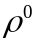 | 0 | 0 | 0
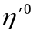 | 0 | 0 | 0
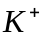 | +1 | 0 | 0
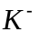 | -1 | 0 | 0
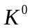 | +1 | 0 | 0
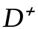 | 0 | +1 | 0
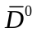 | 0 | -1 | 0
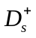 | +1 | +1 | 0
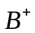 | 0 | 0 | +1
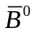 | 0 | 0 | -1
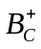 | 0 | +1 | +1

(9) Which force will mediate the following decays? Justify your statement in each case. Also draw the lowest order Feynman diagram for each process. In these diagrams just show how the quarks flow through the interaction; but remember to label them with their flavour and charge. In weak interactions, the quarks from a W decay can appear as a separate final state particle, or they can end up in different particles. The initial state quarks can also “annihilate” to form a W. Finally, you can also produce extra quark – antiquark pairs from gluons….. even in a weak interaction. Many baryons have heavy exited states, e.g. 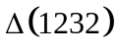 has a mass of 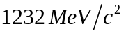. The internal quark structure can be excited to give the heavier 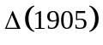 which has the same quantum numbers

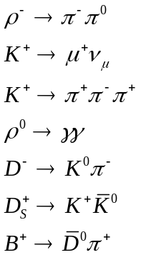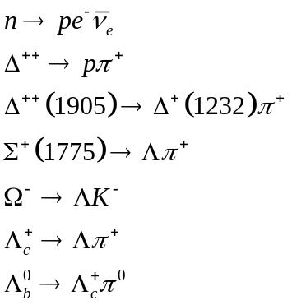

(10) Assign the lepton generation (this is the same as lepton flavour) subscript and distinguish antineutrinos from neutrinos in the reactions and decays and decays on the next page. Use the symbols 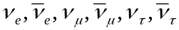. Draw the lowest order Feynman diagram for each process. Where there are mesons or baryons in both sides of the process, just show how the quarks flow through the interaction; but remember to label them with their flavours and charges. The chart at the end of the problem set will help you with this. It is from the book Nuclear and Particle Physics by W.S.C. Williams

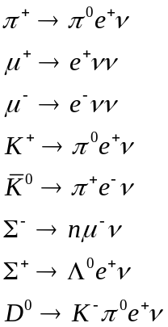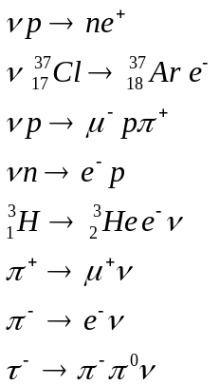

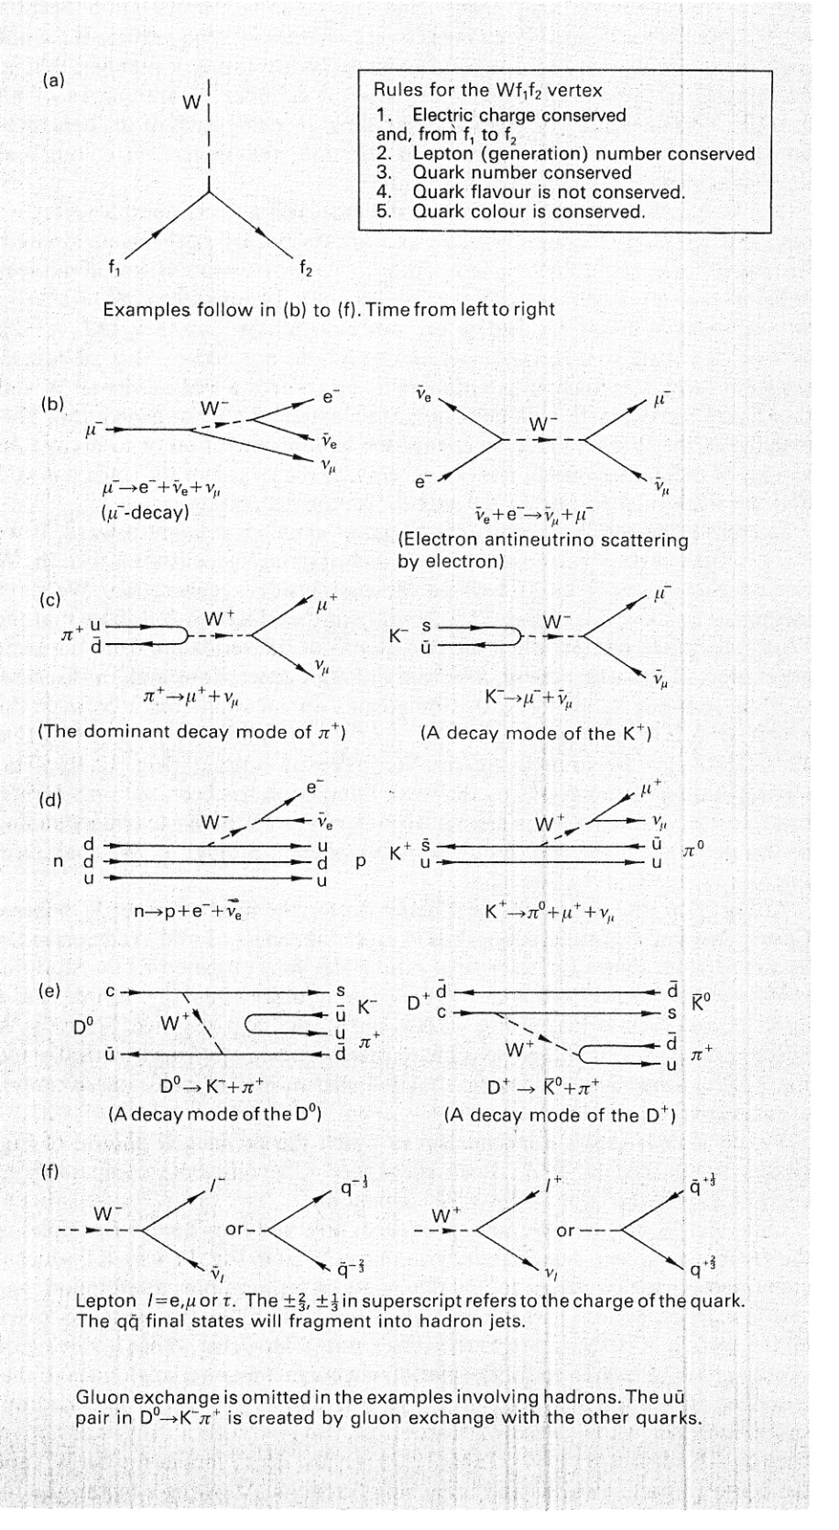

Possibly Useful Physical Constants:

Avogadro No: 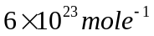
pi 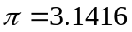
speed of light: 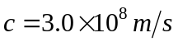
Plank's constant: 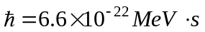
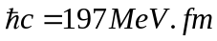
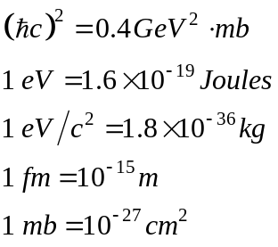
1 year 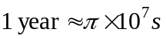
electron charge: 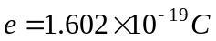
electron magnetic moment: 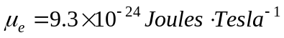
fine structure constant: 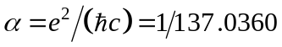
strong coupling constant: 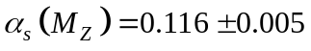
Fermi coupling constant: 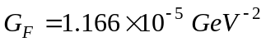
Cabibbo angle: 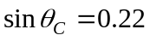
Weak mixing angle: 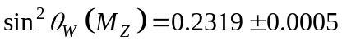
Branching Ratios 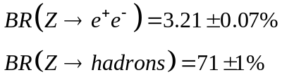
________________________________________________________________________

Particle Properties

Boson | Mass 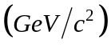 |  | Lepton | Mass 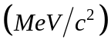
 | 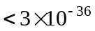 |  | 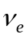 | 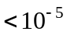
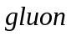 | 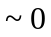 |  |  | 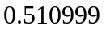
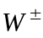 | 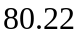 |  | 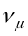 | 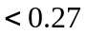
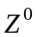 | 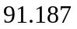 |  |  | 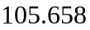
 |  |  | 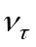 | 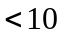
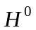 | 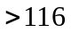 |  |  | 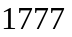

Hadron | Quark Content | Mass | 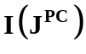
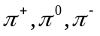 | 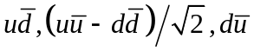 | 139.57,134.97, 139.57 | 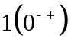
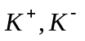 | 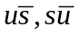 | 493.65 | 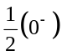
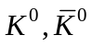 | 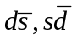 | 497.67
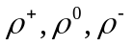 | 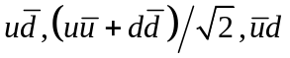 | 775.7 | 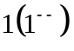
, | 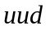,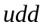 | 938.27, 939.57 | 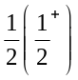
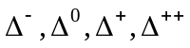 | 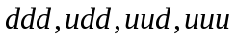 | 1232 | 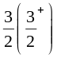
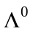 | 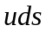 | 1115.6 | 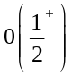
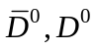 | 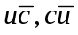 | 1863 | 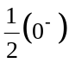
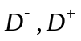 | 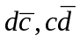 | 1869
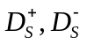 | 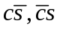 | 1968 | 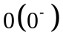
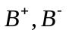 | 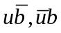 | 5279
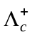 | 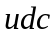 | 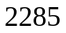
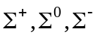 | 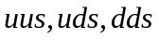 | 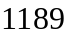 | 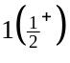
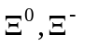 | 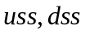 | 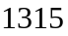 | 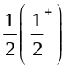
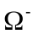 |  | 1672 | 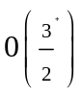
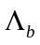 | 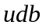 | 5624

